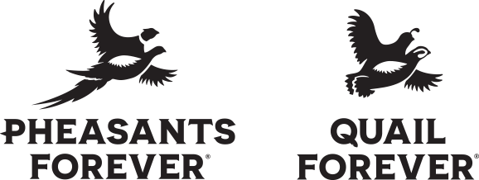

Shooting for a Partnership
Memorandum of Understanding (MOU)

This Memorandum of Understanding (MOU) establishes a mutually beneficial partnership between the _________________________________ PF or QF chapter and the ____________________________ shooting team.
PURPOSE
The purpose of this MOU is to facilitate mutual support for both parties of this MOU by outlining a list of commitments for each.

COMMITMENTS
- The ________________________________________ PF or QF Chapter commits to:
- Sending a chapter representative to a team meeting to inform athletes and parents about our PF and QF mission, our role in wildlife conservation, and promote annual fundraising efforts.
- Providing a leadership opportunity to at least one team member to serve on the chapter committee as a team liaison.
- Financially supporting the shooting team by providing financial support or a fundraising mechanism to the team.
- Providing the team access to PF and QF programs (Learn to Hunt, Learn to Shoot, Banquet, etc.).
- Providing PF or QF youth memberships to the shooting team.

- The ________________________________________ shooting team commits to:
- Providing a PF or QF chapter representative an opportunity to attend a team meeting with parents to talk about the PF/QF mission and share information about fundraising efforts.
- Providing a team captain or other team member to serve as the team liaison on the chapter committee.
- Taking an active role in fundraising efforts that help support the team.
- Supporting the PF or QF chapter by providing a minimum of five team members to assist with at least one chapter sponsored E&O event and the annual fundraising banquet.
- Promoting and attending the chapter’s annual fundraising banquet.

MOU TERMS
This is an “at-will” MOU and may be modified by mutual consent of authorized representatives from both parties. The MOU becomes effective upon signature by both parties and remains in effect for one year from date of signatures.

AUTHORIZATIONS
The signing of this MOU is not a formal undertaking. It implies a spirit of cooperation between both parties, hopefully resulting in a partnership that benefits both.

On behalf of the organization I represent, I wish to sign this MOU and contribute to its further development:

Chapter Name:_________________________________ Chapter President Name:_________________________ Signature:______________________________________ Date:____________________

Team Name___________________________________ Team Coach Name:_____________________________ Signature:_____________________________________ Date:____________________

When completed, please send a copy to Hunting Heritage Program Manager at huntingheritage@pheasantsforever.org

